
HeartStone - the paired Parish of
Sacred Heart and St John Stone

Parish Chosen Charities
Fr Tony, with input from the Parish Open Forum and Parish Vision Team, selected 3 Parish Chosen Charities which the paired parish of Sacred Heart and St John Stone R.C. Churches is supporting in 2019 and 2020. Social events will raise money for each of the 3 Parish Chosen Charities. The chosen charities consist of one International charity: Aid to the Church in Need, ACN and two local charities: Southport Lifeboats and Christ the King High School Chaplaincy

Aid to the Church in Need (ACN)
"The harvest is plentiful, but the labourers are few" Matthew 9:37
Aid to the Church in Need is at work in more than 140 countries, helping Christians who are persecuted, oppressed or in pastoral need.
We will request our donations be focused on ACN’s work in Erbil, Iraq, which includes a camp for Christians who aren’t accepted into the usual refugee camps due to their religion.

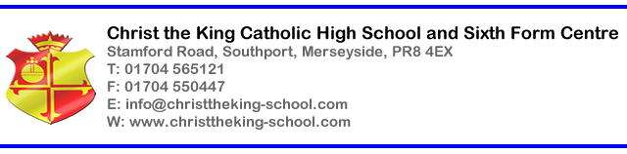
As part of the community of Christ the King, we are part of the worldwide Catholic community. We are a family, working together in love to support each other to be the best we can be. As our motto reminds us, we are Christ the King, with the power to act.

Everything we do is based on the foundation of Christ’s teachings which we find in the Gospels. As the Lord says, it is not God’s will that anybody is lost (Matthew 18:14) but that we are all united with Him. We do this through our faith and our actions.

Chaplaincy is all about opportunity. We want everybody to have a full and abundant life (John 10:10) and this comes from knowing and following God and living out the life He has created us for. We are always available to support our family as we journey through our school life and beyond.
Christ the King Chaplaincy, Mr Dennis Jones, jonesd@christtheking-school.com
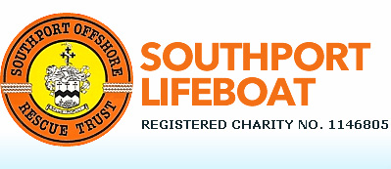
Run by Southport Offshore Rescue Trust, Southport Lifeboat provides a lifeboat and land based search and rescue service around the Sefton coastline.
Independent of the RNLI, they rely on donations and fundraising to support itself to provide a first class life saving service in an area of coast and water covering between the River Mersey and the River Ribble, and up to 25 miles offshore, including Southport Marine Lake.

Southport Lifeboat have helped in the safe return of over 250 people since being formed in 1988, and aim to give crew the best equipment possible to help save lives on our coastline.

Email: info@southport-lifeboat.org.uk
Southport Offshore Rescue Trust
The Boathouse, The Esplanade, Southport, PR8 1RX

The Roman Catholic Archdiocese of Liverpool is committed to keeping your personal data secure. The information you have provided will be kept on file and may occasionally be used to contact you about relevant church services. Please see our Privacy Notice on our website at liverpoolcatholic.org.uk/privacynotice

HeartStone - the paired Parish of
Sacred Heart and St John Stone

Parish Chosen Charities
Fr Tony, with input from the Parish Open Forum and Parish Vision Team, selected 3 Parish Chosen Charities which the paired parish of Sacred Heart and St John Stone R.C. Churches is supporting in 2019 and 2020. Social events will raise money for each of the 3 Parish Chosen Charities. The chosen charities consist of one International charity: Aid to the Church in Need, ACN and two local charities: Southport Lifeboats and Christ the King High School Chaplaincy

Aid to the Church in Need (ACN)
"The harvest is plentiful, but the labourers are few" Matthew 9:37
Aid to the Church in Need is at work in more than 140 countries, helping Christians who are persecuted, oppressed or in pastoral need.
We will request our donations be focused on ACN’s work in Erbil, Iraq, which includes a camp for Christians who aren’t accepted into the usual refugee camps due to their religion.

As part of the community of Christ the King, we are part of the worldwide Catholic community. We are a family, working together in love to support each other to be the best we can be. As our motto reminds us, we are Christ the King, with the power to act.

Everything we do is based on the foundation of Christ’s teachings which we find in the Gospels. As the Lord says, it is not God’s will that anybody is lost (Matthew 18:14) but that we are all united with Him. We do this through our faith and our actions.

Chaplaincy is all about opportunity. We want everybody to have a full and abundant life (John 10:10) and this comes from knowing and following God and living out the life He has created us for. We are always available to support our family as we journey through our school life and beyond.
Christ the King Chaplaincy, Mr Dennis Jones, jonesd@christtheking-school.com
Run by Southport Offshore Rescue Trust, Southport Lifeboat provides a lifeboat and land based search and rescue service around the Sefton coastline.
Independent of the RNLI, they rely on donations and fundraising to support itself to provide a first class life saving service in an area of coast and water covering between the River Mersey and the River Ribble, and up to 25 miles offshore, including Southport Marine Lake.

Southport Lifeboat have helped in the safe return of over 250 people since being formed in 1988, and aim to give crew the best equipment possible to help save lives on our coastline.

Email: info@southport-lifeboat.org.uk
Southport Offshore Rescue Trust
The Boathouse, The Esplanade, Southport, PR8 1RX

The Roman Catholic Archdiocese of Liverpool is committed to keeping your personal data secure. The information you have provided will be kept on file and may occasionally be used to contact you about relevant church services. Please see our Privacy Notice on our website at liverpoolcatholic.org.uk/privacynotice

