
HeartStone - the paired Parish of
Sacred Heart and St John Stone

INDOOR BOWLS
in
St JOHN STONE’S PARISH CENTRE
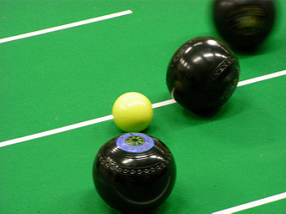

Bowl away The Gloomy Nights!

WHEN? Every Thursday night from October to March.

WHERE? In the Parish Centre at 7.30pm

HOW? By playing Indoor Bowls on the two 45’ x 6’ carpets

All other equipment is provided, as is tuition, for just £1 per night!

Friendly social chat, exercise and competition – with comfortable warm surroundings, thrown in free.

Just turn up at 7.30pm any Thursday to try your hand.

The Roman Catholic Archdiocese of Liverpool is committed to keeping your personal data secure. The information you have provided will be kept on file and may occasionally be used to contact you about relevant church services. Please see our Privacy Notice on our website at liverpoolcatholic.org.uk/privacynotice
HeartStone - the paired Parish of
Sacred Heart and St John Stone

INDOOR BOWLS
in
St JOHN STONE’S PARISH CENTRE

Bowl away The Gloomy Nights!

WHEN? Every Thursday night from October to March.

WHERE? In the Parish Centre at 7.30pm

HOW? By playing Indoor Bowls on the two 45’ x 6’ carpets

All other equipment is provided, as is tuition, for just £1 per night!

Friendly social chat, exercise and competition – with comfortable warm surroundings, thrown in free.

Just turn up at 7.30pm any Thursday to try your hand.

The Roman Catholic Archdiocese of Liverpool is committed to keeping your personal data secure. The information you have provided will be kept on file and may occasionally be used to contact you about relevant church services. Please see our Privacy Notice on our website at liverpoolcatholic.org.uk/privacynotice

