We pray for all Christian leaders. May the Holy Spirit fill them afresh with his love, grace and power.
All: Come, Holy Spirit, fill the Shepherds of the Church anew,
guide them and strengthen them.
Fill them with peace and joy as they lead your people.

We pray for a renewal in the missionary life of the Church. By the power of the Holy Spirit may every Christian, every family and every parish be enabled to witness to Jesus Christ.
All: Come, Holy Spirit, empower us to fulfil your call to be
witnesses to the ends of the earth and proclaim the Good News.

We pray for the culture of life born by the Spirit to penetrate society.
May the Holy Spirit be poured out afresh on all the nations of the earth to renew humanity.
All: Come, Holy Spirit, and renew the face of the earth.
Transform society by the power of your Spirit.

Please feel free to add prayers for the needs of the local neighbourhood.
All: Come Holy Spirit, as by a new Pentecost.


The Lord’s Prayer

“The Holy Spirit also grants the courage to
proclaim the newness of the Gospel with
boldness in every time and place,
even when it meets with opposition.
Let us call upon him today, firmly rooted in prayer…”

Pope Francis, The Joy of the Gospel, 259

PREPARING FOR and
CELEBRATING PENTECOST

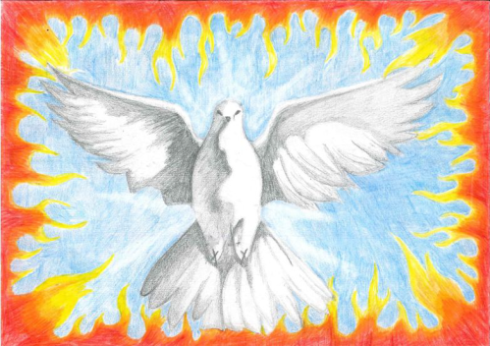

Pope John XXIII’s prayer for the Second Vatican Council
Divine Spirit, renew your wonders in our time, as though for a new Pentecost, and grant that the Holy Church,
persevering in unanimous and continuous prayer, together with Mary the Mother of Jesus, and also under the guidance of St Peter, may increase the reign of the Divine Saviour:
the reign of truth and justice, the reign of love and peace. Amen
…
Cardinal Wiseman's Prayer for England:
O Blessed Virgin Mary, Mother of God and our most gentle Queen and Mother, look down in mercy upon England, thy Dowry, and upon us all who greatly hope and trust in Thee.

By Thee it was that Jesus, our Saviour and our hope was given unto the world; and He has given Thee to us that we might hope still more.
Plead for us Thy children whom Thou did receive and accept at the foot of the Cross O sorrowful Mother.

Intercede for our separated brethren that in one true fold we may
all be united with the chief shepherd of Christ's flock, and that by
faith, fruitful in good works we may all deserve to see and praise God, together with Thee in our heavenly home. Amen.

Cardinal Wiseman 1802-1865 (Archbishop of Westminster)

Following the Command of Christ at his Ascension, like those early disciples we too in our day need to be clothed with power from on high, we too need to be constantly filled with the Holy Spirit.

In preparation for Pentecost we have an opportunity to ‘return to the Upper Room’ in order to pray for a new outpouring of the Holy Spirit in our own lives, upon the Church and the whole world.

Let us always begin our prayer with the Sign of the Cross, into which we are baptised and brought to share in the new life of Easter, the life of the Holy Trinity.

The Sign of the Cross

Leader: In the beginning, at creation, you hovered over the water.
All: Come Holy Spirit, as by a new Pentecost.

Leader: You breathed into Adam a breath of life.
All: Come Holy Spirit, Breath of God, breathe in us today.

Leader: You anointed the prophets and kings.
All: Come Holy Spirit, anoint us for your service.
Send us anew to bring good news to the poor.

Leader: To Elijah you came with the sound of a gentle breeze,
to the Apostles with the sound of a mighty wind.
All: Come Holy Spirit, in your gentleness and might.
Leader: You are the living water,
the river of life that brings fruitfulness and joy.
All: Come Holy Spirit, flow freely in your Church.

Leader: You overshadowed Mary at the Annunciation.
All: Come Holy Spirit, overshadow us today with your power,
that the will of God may be accomplished in us and through us.

Leader: You appeared as a dove at the baptism of Jesus Christ.
All: Come Holy Spirit, fill the world anew with the gift of your peace.
Leader: You came at Pentecost fulfilling the promise of the Father.
You filled the disciples of Jesus who had gathered in prayer
and appeared with tongues of fire.
All: Come Holy Spirit, lead us anew to Jesus Christ.
May we be baptised with the Holy Spirit and fire.

Leader: You are the love of God poured into our hearts.
All: Come Holy Spirit, make us one.
Fill us and empower us with your presence
that we may live in love as sons and daughters of God.

All: Come, Holy Spirit, fill the hearts of your faithful.
And kindle in us the fire of your love.
Send forth your Spirit and we shall be created.
And you will renew the face of the earth.

Leader: Let us pray:
All: O God, by the light of the Holy Spirit, you instruct the hearts of your faithful, grant that by that same Holy Spirit, we may grow truly wise, and ever rejoice in your consolation.
Through Christ our Lord. Amen.

Prayers of Intercession
Leader: We pray to the Lord, asking that the gift of the Holy Spirit be poured out afresh on the Church and the whole world: We pray for a new Pentecost in the Church, that the culture of Pentecost may renew the whole Church in prayer, holiness, communion and mission.
All: Come, Holy Spirit, rekindle your fire by a New Pentecost
and renew your Church.

We pray for Christian unity, for reconciliation and the healing of divisions in the Body of Christ. By the power of the Holy Spirit may all disciples of Jesus be one in heart, mind and soul.
All: Come, Holy Spirit, unite your Church,
make us one that the world may believe.

